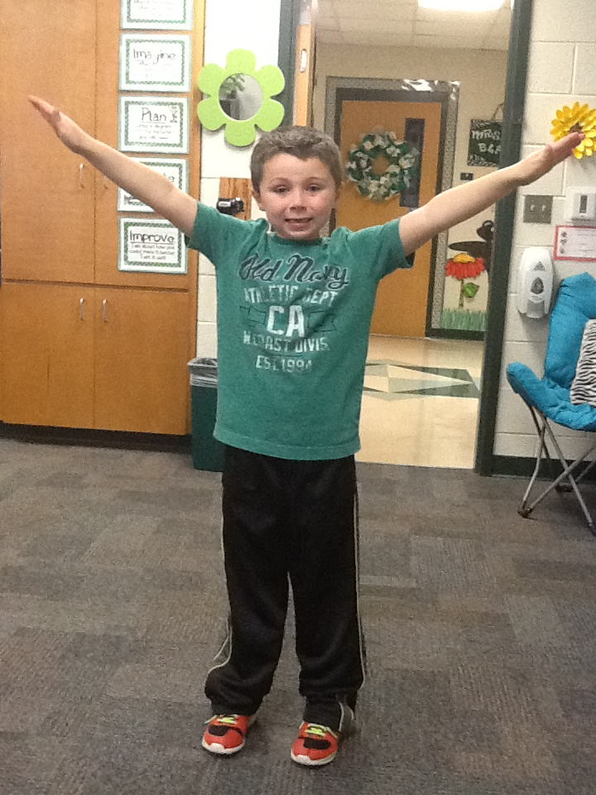 

+

**PARENT INFO:**

The TAGT (Texas Assoc. for the Gifted & Talented) website has multiple resources for parents of gifted children. Be sure to check them out at <http://txgifted.org/web-resources-parents/>

Be sure to check our webpage often. Find it at [www.pisd.net](http://www.pisd.net) on the Elementary page under the Programs/ Services tab.

**Wednesday**

**10:45-12:15**

**Friday**

**8:15-9:00**

**Wednesday**

**8:20-9:50**

**Wednesday**

**1:45-2:30**

1st

Grade

2nd

Grade

## **Third Grade News**

**Mrs. Gentry’s GATE**

**Class**

+

**GATE Newsletter**

September 25, 2015

**GATE Schedule:**

3rd

Grade

**Each class will include a variety of activities that challenge students and promote divergent, analytical and critical thinking .**



**The third grade GATE class will continue working with our LEGO Engineering curriculum and LEGO journal. We will begin studying different fields of engineering, and how they impact our world. We will also focus on inventions and inventors.**

**We will complete various STEAM (Science/Technology/Engineering/ Art/Math) activities during class that will incorporate LEGOs and many other materials.**

**Third grade will meet on Fridays to study newspapers, social media, and how each one is used to keep us informed about the world around us. I will keep you updated on our plans for that.**

**GATE classes begin next week! I am so excited to meet my students and get to work! I know this is going to be a great year in GATE!**



**The second grade GATE class will begin an ongoing LEGO Engineering project that will continue throughout third grade. They will put together a LEGO Engineering notebook that will showcase the quotes, vocabulary, websites and LEGO creations that are a part of each class. The LEGO curriculum will cover all subject areas.**

**Second grade will also spend time at Brain Stations where they will work on various activities including technology, puzzles, art, etc. We will play challenging games that require both deep and quick thinking strategies, as well as solve intriguing brain teasers.**

### First Grade News

**The first grade GATE class focuses on enrichment in all subject areas. We will use LEGOs as an introduction to engineering and enjoy a building challenge each week. We will solve logic puzzles and spend time stretching our vocabulary and playing word games. Our Brain Stations will offer opportunities to use technology, solve higher level math problems and conduct scientific experiments.**

**LEGOs**

**We**

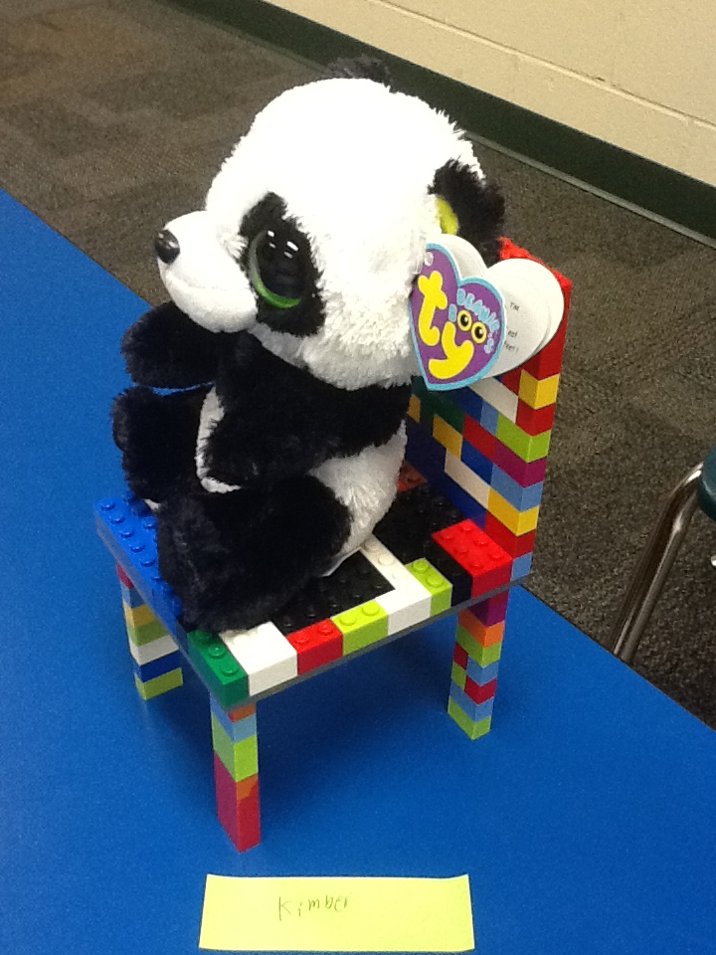

**A NOTE FROM MRS. GENTRY:**

**I am looking forward to an exciting year in GATE. I have high expectations for my students and I am looking forward to watching them grow and succeed!**

**My goal this year is to add more service projects to our curriculum and involve my students in each step of making that happen.**

**I will be working closely with the classroom teachers to differentiate instruction for your child’s gifted area, and I look forward to working with you. We are a team with your child’s best interests at heart and we all want each student to be successful.**

**Please feel free to contact me if you have any questions.**

**Carla Gentry**

[**cgentry@pisd.net**](mailto:cgentry@pisd.net) **940-969-5046**

### Second Grade News